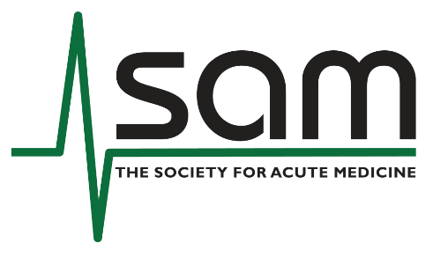
Society for Acute Medicine (SAM)
Small Grants Application Form

Application Title (limited to 120 characters):
Main Applicant:
Name:
Position:
Contact Details (email/phone):
SAM Membership Number:
Co-Applicant(s): (Name, Position, Organisation, Contact details)
Host Organisation:
Is this an application for funding or for application development support? (delete as appropriate)
Research funding / Research application development support
If the application is for research funding, please complete all sections.
If this application is for Research Application Development support, please complete as much as you can at the current time, noting the deadlines remain the same for this round.

Research Details (300 words each)
Research Question:
Project Aims:
Background: (Provide context and rationale for the project)
Methodology: (Briefly describe the research approach and methods)
Likely Outputs: (What outputs will the project generate, e.g., publications, guidelines, toolkits)

Additional Criteria (300 words each)
Relevance to Acute Medicine: (Explain clearly how the project aligns with and benefits acute medicine)
Contribution to Capacity Building in Acute Medicine: (Describe how the project will strengthen skills, knowledge, or resources within the acute medicine community)

Budget (add rows as needed)
Item Description | Cost (£)
Total Requested (£):

Attachments Required:
- Project timeline (Gantt Chart)
- One-page CV of Main Applicant
- Letter of Support from Host Organisation
Declaration:
I confirm that the information provided is accurate, and the host organisation supports this application.
Signature:
Date:

Applications to be returned to administrator@acutemedicine.org.uk
Deadline: 16th January 2026

