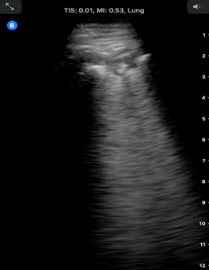
FUSIC heart and FAMUS combination courses

21nd-22^{ed} September 2021, Lakeside International Hotel, Frimley

Target audience: All clinicians interested in Point of Care Ultrasound, including PAs .

Aims:
- Establish your skills to deliver a focused bed-side US study in the unwell patients.
- Focus on the triple scan approach (Heart-Lung-IVC) to dyspnoea

Pre-course learning:
- FUSIC Heart module – ICE-BLU e-learning module (e-lfh.org.uk) and Intensive Care Society FUSIC Heart module online lectures (£10).
- FAMUS – FAMUS e-learning package and assessment (e-lfh.org.uk) and online lectures.

Sessions:
- Small teaching groups (max 3 per group) to maximise scanning time with state-of-the-art US machines and hand handle devices.
- Expert faculty from Intensive Care, Acute Medicine and Emergency Medicine.
- Half-day of non-stop practice on models, simulated clinical scenarios and phantoms

Mentorship: Possibility of hiring a Butterfly IQ probe for collecting cases for accreditation and enrolling into remote mentorship (REsUS initiative). More info on www.pocusfrimley.com

Prices:
- FUSIC Heart (day 1, morning or afternoon session) – £315.
- FAMUS-FUSIC lung & abdomen (day 2, morning or afternoon session) – £325.
- Both days: £550.

To register: on line registration and payment on www.pocusfrimley.com

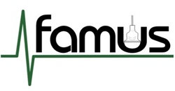
C
Full programme and information on: www.pocusfrimley.com

