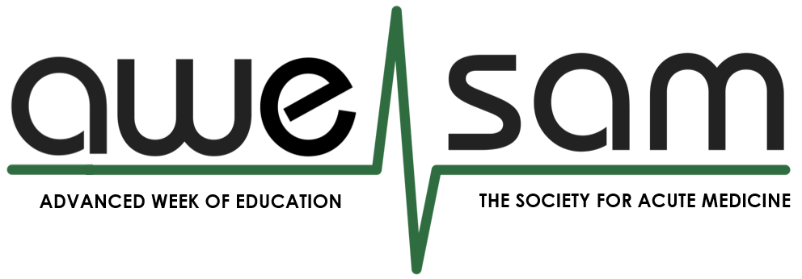
The Finishing School for Acute Physicians
AWESAM is a residential finishing school for Acute Medicine doctors within 18 months of CCT. Designed by AIM consultants with a focus on leadership and the non-clinical aspects our work. Having encountered some challenges during our own careers, we wanted to share the practical realities of becoming a consultant, and to support SAM members in building the confidence, skills and professional network you'll rely on throughout your career.
What: Residential finishing school for your transition to become an NHS Acute Medicine Consultant  Price: £200* for SAM members - accommodation and all meals included!  Who: AIM registrars and portfolio pathway doctors within 18 months of CCT  When: 16–19 November 2026  Where: Wedderlie House, Scottish Borders  Places: Limited to 20 participants  Questions: education@acutemedicine.org.uk | REGISTER HERE  Application Deadline 24/8/26
  
*Subsidised by SAM for members, reflecting our commitment to equitable access to high-quality education. A bursary may be available in exceptional circumstances — please contact us in confidence.
Eligibility
- AIM trainees and portfolio doctors (including CESR) within 18 months of CCT.
- Current SAM membership is required.
- Attendance on a residential basis for the full duration of the course is mandatory.
- Completion of approximately 2–3 hours of pre-course reading is expected.
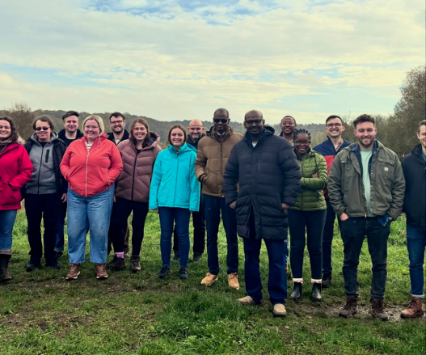 | an awesam experience…  ✅ 100% of previous delegates would recommend the course!  ⭐ 100% rated the faculty as excellent or very good  🎓 Designed specifically for Acute Medicine  🤝 National faculty and peer networking  💼 Focused on the non-clinical skills needed as an AIM consultant

“This was the best course I have ever attended in my entire career.”
“...I feel incredibly lucky to have attended.”
-AWESAM attendee
The aweSAM curriculum
Preparing for Consultant Practice — job applications, consultant interviews, job planning, salary negotiation, contracts, appraisal and everything you need before your first consultant post.
Becoming the Consultant — making the transition from registrar to consultant, supervising trainees, difficult conversations, giving feedback and leading the multidisciplinary team.
Leading Improvement — quality improvement, interpreting performance data, business cases, service development and influencing change.
Leading the Shop Floor — stepping into the consultant role, decision-making, managing flow and leading the acute medical team.
Healthcare Leadership & Politics — understanding NHS structure and management, with Q&A sessions from board-level Medical Directors and members of SAM Executive Council.
Building a Sustainable Career — impostor syndrome, resilience, work-life balance and developing a career that is rewarding.
Building Your Consultant Network — creating the peer group and professional relationships that will support you throughout your consultant career.
What We Wish We'd Known — an honest discussion about complaints, coroner/procurator fiscal requests, difficult situations and the realities of consultant practice that no textbook covers.
More than a course…
We recognise that it can be challenging to step away from home and work commitments for a few days. However, we also know that some of the most valuable learning happens outside of the structured sessions, through shared meals, informal discussions, peer support, and networking with colleagues who are navigating the same transition.
Attendance on a residential basis for the full duration of the course is a condition of acceptance. Please only apply if you are able to stay on site and participate fully in the programme, including all evening activities and meals.

If exceptional personal circumstances or accessibility requirements affect your ability to attend on a residential basis, please contact us before applying.
Applications
Applications include a 500-word personal statement outlining:
REGISTER HERE
Application Deadline 24/8/26
• Why you are applying to AWESAM
• Your learning and development goals
• What you hope to contribute to the group
Places are limited to 20 participants, to preserve the benefits of small-group learning, ensuring everyone has the opportunity to participate, receive personalised feedback, and build meaningful relationships with both faculty and peers.
This does mean that places are competitive, and your application will be assessed based on your supporting statement.
Priority will be given to previous unsuccessful applicants, those with only one AWESAM opportunity remaining before CCT, doctors returning from time out of training, and those requiring a recognised leadership course to complete their training (usually supported by a statement from their TPD).

