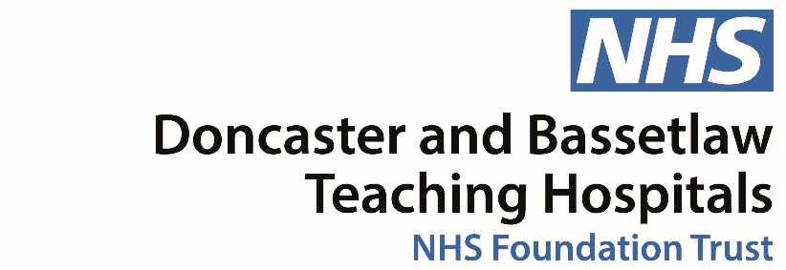
Become a Trust member and make a difference to the care our hospitals provide.
Email dbth.TrustBoardoffice@nhs.net for more information about membership

Doncaster and Bassetlaw Teaching Hospitals
FAMUS Booking Form
Please complete in BLOCK CAPITALS and return with payment or confirmation of payment to Education Centre, Doncaster Royal Infirmary, Armthorpe Road, Doncaster, South Yorkshire, DN2 5LT

NAME………………………………………………………………………………………………………………………………………………………………………..
JOB TITLE…………………………………………………………………………………………………………………………………………………………………..
ADDRESS……………………………………………………………………………………………………………………………………………………………………
………………………………………………………………………………………………………………………………………………………………………………….
………………………………………………………………………………………………………………………………………………………………………………….
MOBILE…………………………………………………………………………………………………………………………………………………………………….
HOSPITAL…………………………………………………………………………………………………………………………………………………………………

FAMUS Course
On 17/September/2021
Total Cost £250.00
Please make cheques payable to Doncaster and Bassetlaw Teaching Hospitals NHS Foundation Trust
For credit card payment please contact 01302 642118 quoting reference 195815.4558.A6289
To arrange invoice payments please contact Alison Barlow Alison.barlow1@nhs.net or 01302 642046

